
TRAUMA GRAND ROUNDS

The ANZAST Trauma Grand Rounds are a series of live, online broadcasts presented bi-monthly.

Delivering Trauma Care in Gaza

Tuesday 3rd June 2025
6:00pm-7:00pm AEST; 8:00-9:30pm NZST

Keynote Adress: Dr Bushra Othman

Dr Bushra Othman is an Australian Palestinian general surgeon, based in Melbourne, Victoria.

Dr Othman is a board member of the Palestinian Australian and New Zealand Medical Association (PANZMA) and was the first female of this organisation to volunteer in Gaza. She has subsequently returned on multiple occasions as a volunteer surgeon. Dr Othman is dedicated to humanitarian and community service both internationally as well as locally. She has been an invited speaker for GSA and RACS and has appeared on 774 Melbourne.

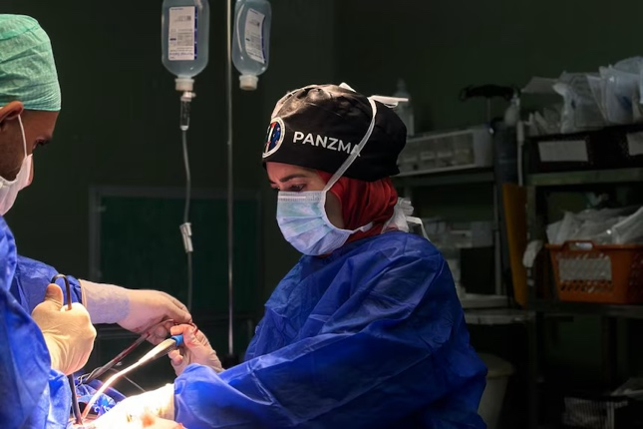

Panellist:
Dr Mary Langcake
Mary Langcake is the Director of Trauma at St George Hospital after training in Upper GI and Transplant Surgery, Sydney a role she has held since 2009. She is a Fellow of both the Royal Australasian College of Surgeons and the American College of Surgeons.
As a Wing Commander in the Royal Australian Air Force, Mary had front line experience as a military surgeon in Afghanistan in 2008. She is a Past Chair of the Royal Australasian College of Surgeons, NSW Regional Committee. She is a member of numerous committees, including the St George Hospital Clinical Council, the NSW Institute of Trauma and Injury Management (ITIM) Clinical Review Committee, and the RACS Surgeons as Educators Committee.
Mary is strongly committed to the education of medical, nursing, and allied health staff and is currently enrolled in a Master of Surgical Education at the University of Melbourne. Mary has previously had roles as chair of the RACS NSW Education and Research Committee, and as a member of the ITIM Executive Committee. She is a Director on EMST and an instructor on DSTC Courses.
In addition to her many roles, Mary is a strong advocate for the wellbeing of doctors, which has included calling for better understanding of psychological distress within the profession.

.

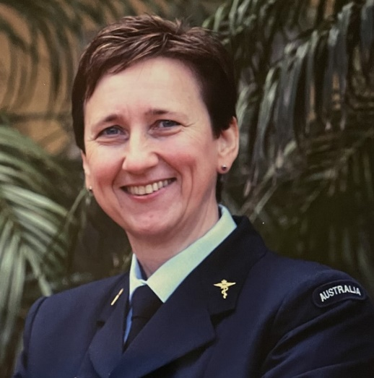

Program:

Introduction: 18:00-18:05
Acknowledgement of country, Dr Kate Martin, President, ANZAST.
Welcome, introductions and housekeeping: Dr Martin Jarmin

Keynote Presentation: 18:05-18:40
Dr Bushra Othman
Dr Mary Langcake

Panel Discussion: 18:40-18:55

Close: 18:55

Supported by the Royal Australasian College of Surgeons


Link for registration:
https://us06web.zoom.us/webinar/register/WN_7hJabLcFQ1WBq9j-ULq_DA

